Contents

1. INTRODUCTION 2

1.1 Justification of project 2

Background of the project 2

1.2 Problem statement 2

1.3 Description of the project 3

1.4 Overview of the project 3

2. Scope of the project 3

2.1 Scope 3

2.2 Limitation 3

2.3 Aim 3

2.4 Objectives 3

2.5 Overview of the scope 4

3. Development Methodology 4

3.1 Waterfall method 4

2.2 Design pattern 5

2.3 System architecture 6

4. Project plan 7

4.1 Work breakdown structure 7

4.2 Milestones 9

4.3 Scheduling/ Gantt chart 11

4.4 Time estimation table 12

5. Risk management 14

6. Configuration management 15

7. Conclusion 18

References 19

# INTRODUCTION

**Project introduction**

Now world has changed into modern technology as known as smart city. people wants stress less and easy life. Nowadays people can easily get whatever they want just by sitting inside at house without any problems. As I said before smart city, people uses mobiles, laptop and others technology for buying products not only this due to the modern technology, people can order or book the food through the online at any time or anywhere. The project tittle "ONLINE FOOD ORDERING SYSTEM " where all the costumer can order food any time.

## 1.1 Justification of project

### Background of the project

ONLINE FOOD ORDERING SYSTEM is web page where we can order different types of foods. And you do not have to stay in long queue. Oder must delivery in given time and told location.

It is very easy application to use. Only you have to login and register and can see the food which want to order and other process. No need to wait long and your food on time.

its user interface design is very well and can interact easily. Easily can get the food anywhere you want. I have used MY SQL for database and php programming code.

## 1.2 Problem statement

The problems of the current system of customers are they cannot able to see their meals, ingredients and they only have to pay the for an online order. Most of the people ordered the food from the online, there may be problem to delivered on time. There must be problems to order food due to the fault of server.

## 1.3 Description of the project

**Features**

* User can login to the system
* User can order the food from anywhere
* Drones for delivery
* User can Secure reservation through online

## 1.4 Overview of the project

In this project, there are many features to the customers to get the food easy way. User can login and view the menus and select the food items of their choice. Customer can easily order the food. There were delivery services. They can order the food anywhere at any time.

# Scope of the project

## 2.1 Scope

Online Food ordering system is for to order the food easily and can able to view the menus and ingredients. Can confirm that the order was place correctly. The main language of programming this system is PHP.

## 2.2 Limitation

There must be internet connection to order the food.

## 2.3 Aim

The main aim of this project are:

* Order the food from online anywhere at any time.
* It reduces the number of staff.
* People can get their own food on time without any queue.
* System will provide all the details information about the mood and can view the menu.

## 2.4 Objectives

The main objectives of this system are:

* To manage all the customer, food and others.
* And also manage all details information related to customer, food, price, time.
* The other objectives are customer can easily get the food from their own location.

## 2.5 Overview of the scope

In this project there were limitations, aims and objectives. To order the food must have the internet connection. Aims reduces the staff and more. Objectives is to manage all the things like food, customer and any more. In previous period, many people have to stay in queue to order food but in today's world technology has ruled the world. so, on the basis of technology I thought to make my project in online food delivery which is fast process for people and they don’t have to wait for a long time.

# Development Methodology

## 3.1 Waterfall method

For this project I have used waterfall model. This model is sequential model where the one step must have finished then only another step should begin. In that model all the steps are divided. There are six steps in this model they are: requirements, Analysis, Design, Implementation, Testing, Deployment.

I have chosen the waterfall model because it helps find out the mistakes easily of the project. It is easy to use to the small project. This model suits for the small project. Easy to understand. Waterfall model is first approach used in the software development.

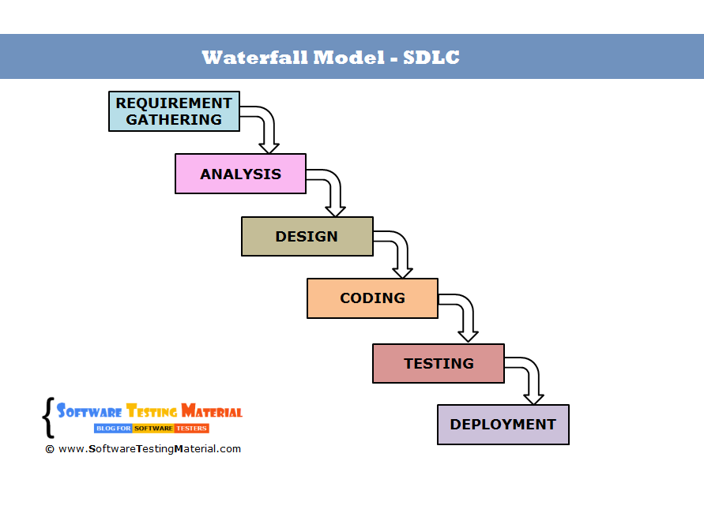

Figure 1: waterfall model

First collected all the requirements and then analysis. Analysis phase finished then next step design. After that coding phase. When all the code done then next step is testing. Many testing are there when all the testing finished then next step. Last step deployment step.

## 2.2 Design pattern

Design patterns are the reusable solution to software design. In this project I am using **MODEL VIEW CONTROLLER PATTERN**. It is very used framework in software development. It used on both desktop and web-based application.

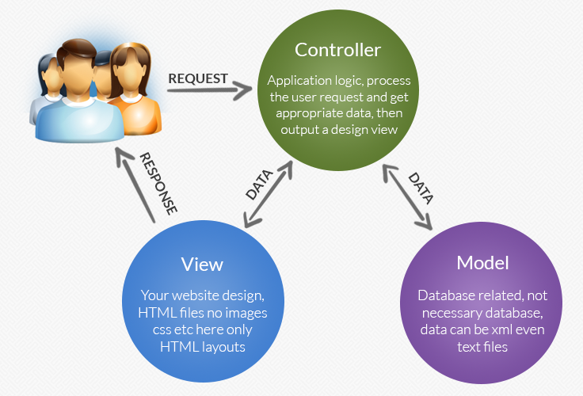

Figure 2: Model View Controller

**Model:**

Handles all the data related that the user work with.

**View:**

Handles all the application of UI logic.

**Controller:**

It acts as middle between model and view to method arriving requests and logic.

## 2.3 System architecture

It is a conceptual model that defines the structure, behavior and view of the system. It is a representation of a system. It defines the structure of a software system. This is usually a series of diagrams that illustrate services, components, layers and interactions. A systems architecture document may also cover other elements of a solution including business architecture, technology architecture, security architecture and data architecture.

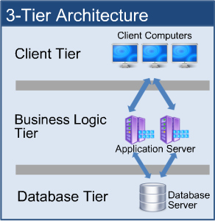

Figure 3:3_tier architecture

# Project plan

## 4.1 Work breakdown structure

Work breakdown structure. A work-breakdown structure (WBS) in project management and systems engineering, is a **deliverable -oriented breakdown of a project into smaller components**. A work breakdown structure is a key project deliverable that organizes the team's work into manageable sections.

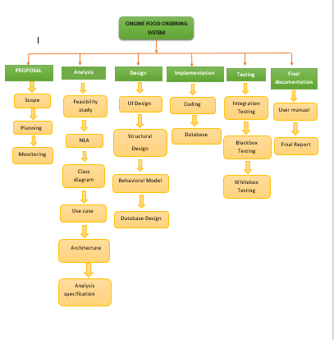

Figure :wbs structure

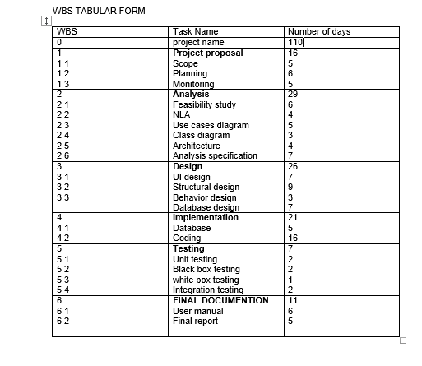

Figure :WBS structural tabular form

In WBS structural tabular form, divided the days according to their task. As you can see there were different tasks and have to complete the work according to these days. This helps a lot to do task and make our work easy.

## 4.2 Milestones

|  |  |  |  |  |
| --- | --- | --- | --- | --- |
| S.N | Title | Start | Deadline | No.of Days |
| 1 | Project proposal | 25th march | 9th April | 16 days |
| 1.1  1.2  1.3 | Scope  Planning  Monitoring | 25th March  30th March  4th April | 29th March  4th April  9th April | 5  6  5 |
| 2 | **Analysis** | 10th April | 8th May | 29 days |
| 2.1  2.2  2.3  2.4  2.5  2.6 | Feasibility study  NLA  Use cases  Class diagram  Architecture  Analysis specification | 101h April  16th April  20thApril  25th April  28th April  2nd May | 15th April  19th April  24th April  27th April  1st May  8th May | 6  4  5  3  4  7 |
| 3 | **Design** | 9th May | 3rd June | 26 days |
| 3.1  3.2  3.3  3.4 | UI design  Structural design  Behavior design  Database design | 9th May  16th May  25th May  28th May | 15th May  24th May  27th May  3rd June | 7  9  3  7 |
| 4 | **Implementation** | 4th June | 24th June | 21 days |
| 4.1  4.2 | Database  Coding | 4th June  9th June | 8th June  24th June | 5  15 |
| 5 | **Testing** | 25th June | 1st July | 7 days |
| 5.1  5.2  5.3  5.4 | Unit testing  Black box testing  white box testing  integration testing | 25th June  27th June  29th June  1st July | 26th June  28th June  30th June  1st July | 2  2  1  2 |
| 6 | **FINAL DOCUMENTION** | 2nd July | 12th July | 11 days |
| 6.1  6.2 | User manual  Final report | 2nd July  8th July | 7th July  12th July | 6  5 |

**Description of Milestones**

**Proposal project:**

I divided 16 days for the project. 5 days for scope, 6 days for planning and 5days for monitoring.

**Analysis:**

I have decided 28 days for analysis. In analysis many things to do that’s why need more than other task. 6 days for feasibility study, 4 days for NLA, for use case diagram 5 days, 3 days for class diagram, 4 days for architecture and 6 days for analysis specification.

**Design:**

Many designs to do so I allocate 25 days for designing. 7 days for UI design, 9 days for structural design, 3 days for behavior design, 6 days for database design.

**Implementation:**

For database 5 days and coding for 15 days.

**Testing:**

Estimated the days, 2 days for unit testing, 2 days for black box testing, 1-day white box testing and 2 days for integration testing.

**Final Documentation:**

11 days for the final documentation. 6 days for user manual and 5 days for Final report

## 4.3 Scheduling/ Gantt chart

A Gantt chart is a useful graphical tool which shows activities or tasks performed against time. It is also known as visual presentation of a project where the activities are broken down and displayed on a chart which makes it is easy to understand and interpret.

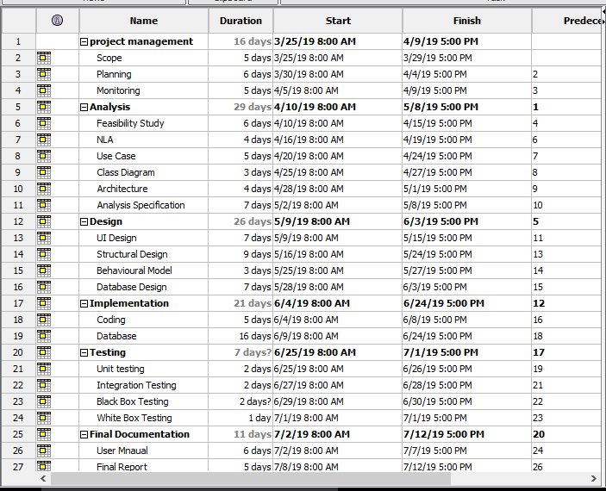

Figure : Gantt Chart

On the chart, tasks are shown on the vertical axis while the scheduled time-spend is laid out on the horizontal axis. Each task is represented by a bar that shows the time required for the project.

## 4.4 Time estimation table

This the time estimation table which shows the times. Easy way to know the time about the projects. It is very useful and important in the project. It helps a lot in make the project.

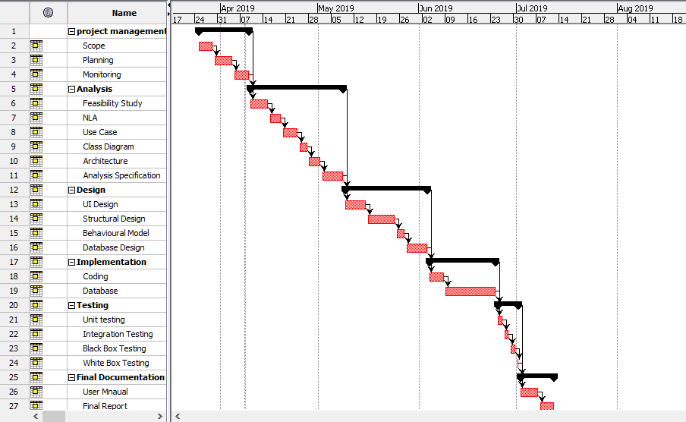

Figure : Time estimation

# Risk management

It identifies the risk and analyzed risk factor in the project. It is also one of the part of this process. It helps to figure out the problems and risks in upcoming future.

**Some possible risks:**

* Managing the products
* Wrong delivery
* Time consuming
* Server failure
* lack of skill

**Impact = Likelihood * Consequence**

**Risk likelihood table**

|  |  |
| --- | --- |
| **likelihood** | **values** |
| Low | 1 |
| Medium | 2 |
| High | 3 |

**Consequence table**

|  |  |
| --- | --- |
| **Consequence** | **Values** |
| Very Low | 1 |
| Low | 2 |
| Medium | 3 |
| High | 4 |
| Very High | 5 |

**Risk Consequence values**

|  |  |  |  |  |  |
| --- | --- | --- | --- | --- | --- |
| **S.N** | **Risks** | **Likelihood** | **Consequence** | **Impact** | **Actions** |
| **1** | Server failure | 1 | 4 | 4 | Backup should be done |
| **2** | Wrong delivery | 2 | 4 | 8 | Give proper information |
| **3** | Lack of skill | 1 | 3 | 3 | provide the training for employees |
| **4** | Timing | 2 | 4 | 8 | Divide the time for different employees |
| **5** | Manage the products | 2 | 4 | 8 | Provide proper information about products |
|  |  |  |  |  |  |

# Configuration management

It is systems engineering method for confirming consistency among the assets physical and logical in an operational environmental. It helps identify bad configuration quickly. It is the collection of techniques and tools whose main target is to conform the consistency of the requirements systems. It is used to control documentation of a product.

**The steps of Configuration management are:**

* Configuration management planning and Management.
* Identification of Configuration.
* Configuration Control.
* Verification and audit.

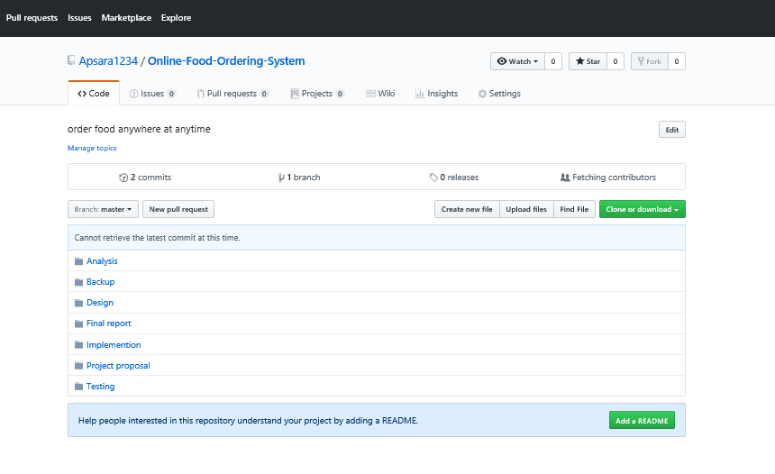

Figure : MBS on GitHub

This is screenshot of the folder that I have push in the GitHub. As you can see there are seven folders. So, this is my whole project.

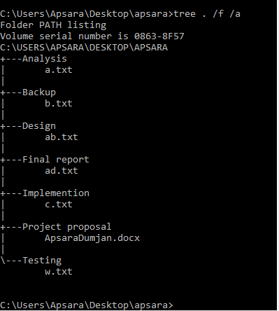

Figure : Tree structure

GitHub id: https://github.com/Apsara1234/Online-Food-Ordering-System

# Conclusion

Online Food Ordering system is web application where anybody can order the food from anywhere at any time. It saves the time and easy to use. reserve services. I have divided the works to make the work easy and used MVC design pattern. limitation is you have internet connection to order the food. There are many features to the customers. There are aims and objectives also. Made the Gantt chart and time estimation to know the time and divide the days according to their tasks. I am using PHP and MY SQL may be others too.

# References

Anon., 2016. *Gantt Chart.* [Online]   
Available at: https://www.investopedia.com/terms/g/gantt-chart.asp  
[Accessed 29 march 2019].

Anon., 2017. *3-Tier Architecture: A Complete Overview - JReport.* [Online]   
Available at: https://www.jinfonet.com/resources/bi-defined/3-tier-architecture  
[Accessed 1 april 2019].

Anon., 2017. *Model-View-Controller.* [Online]   
Available at: https://developer.apple.com/library/archive/documentation/General/...  
[Accessed 3 april 2019].

Anon., 2018. *Work Breakdown Structure.* [Online]   
Available at: https://en.wikipedia.org/wiki/Work_breakdown_structure  
[Accessed 27 march 2019].

Waliaula, B., 2017. *ONLINE ORDERING SYSTEM PROJECT PROPOSAL.* [Online]   
Available at: https://www.academia.edu/4935972/ONLINE_ORDERING_SYSTEM_PROJECT  
[Accessed 5 april 2019].